#include<iostream>

using namespace std;

void charfind()

{

char array[5], key;

for (int i = 0; i<5; i++)

{

cout << "Enter five characters ";

cin >> array[i];

}

cout << "Enter the key value ";

cin >> key;

for (int i = 0; i<5; i++)

{

if (array[i] == key)

{

cout << "character found" << endl;

}

}

}

int main()

{

char array[5], key;

charfind();

}

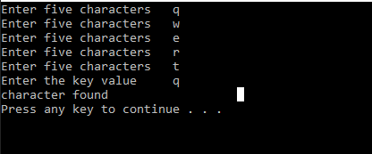

**Task 2**

#include<iostream>

using namespace std;

int main()

{

int array[10], sum = 0, avg;

for (int i = 0; i<10; i++)

{

cout << "Enter integer values";

cin >> array[i];

sum += array[i];

}

cout << "The sum of numbers are" << sum << endl;

avg = sum / 10;

cout << "The mean of numbers are" << avg << endl;

cout << "the median of the number is" << array[4];

system("pause");

}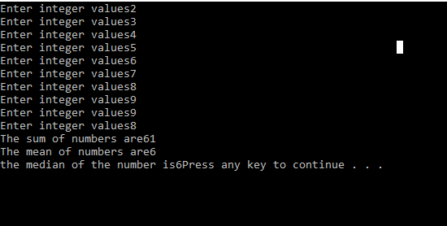

**TASK 3**

#include<iostream>

using namespace std;

void vectors()

{

float v1[2], v2[2], ab = 0, x = 0;

int i = 0;

cout << "Enter 1st vecotr in form of x,y,z" << endl;

for (i = 0; i < 3; i++)

{

cin >> v1[i];

}

cout << "Enter 2nd vector in form of x,y,z" << endl;

for (i = 0; i < 3; i++)

{

cin >> v2[i];

}

for (i = 0; i < 3; i++)

{

x = v1[i] * v2[i];

ab = x + ab;

}

cout << "vector product (a.b) = " << ab << endl;

}

int main()

{

vectors();

system("pause");

}

